# Table of Contents

Introduction 2

Scenario 3

Scope 4

In Scope 4

Non-Functional Requirements 4

Form design 4

Customer Details Form 4

Login Form 5

Gym Form 6

Class Diagram 7

Classes 8

CalculatorEngine.cs 8

Customer.cs 9

EnteringDetails.cs 10

ESCGym.cs 11

Login.cs 12

Utility.cs 13

Validator.cs 14

Properties 14

Adding properties 14

CalculatorEngine properties 14

Customer properties 15

Methods 16

RoundValue : double 16

GetBMICategory : string 17

BMR_HB : double 17

Testing 18

NUnit - Unit Tests 18

CalculatorEngineTest.cs 18

CustomerTest.cs 19

UtilityTest.cs 21

ValidatorTest.cs 21

Review 22

Richard’s Review 22

What went well 22

Development 22

Database Schema 22

QA Testing 22

What didn't go well 22

Project Management 22

Development 22

QA Testing 22

# Introduction

This is a report of my assignment “East Surrey College GymApp” that I worked on at Infor.

ESC GymApp is a Windows Forms application written in C# using Visual Studio 2017. I was tasked to produce a piece of software using the contextual scenario below and follow all professional computing standards and good practice procedures set by Infor. The finished solution consists of the frontend (GUI) and the back-end (code).

# Scenario

You are asked to use your software design, development, testing and evaluation understanding and skills to produce a program that meets the client’s requirements.

East Surrey College gym has commissioned you as a software developer to write a program that will assess a gym member’s requirement to maintain their current weight accurately.

You need to create a program that will give the learners gym member information about:

• Their current basal metabolic rate (BMR)

• Their current body mass index (BMI)

• Their target BMI

• The number of kilocalories to maintain their current weight.

# Scope

## In Scope

## The program calculates and displays a gym member's basal metabolic rate (BMR)

## Calculates and display the gym member's body mass index (BMI)

## The number of kilocalories to maintain their current weight.

## The BMR calculation is given to 2 decimal places.

## The BMI calculation is given to 1 decimal place.

## The kilocalorie requirement output is shown rounded to a whole number.

## The program needs a "login" screen to access the application.

## A screen to collect customer details, if they're an existing gym member, name, address, email and telephone.

## Out of scope

* Create a user account
* Print information
* View help

## Non-Functional Requirements

## Must be Windows Form application written in C# or Java

# Form design

## First iteration

The first iteration of form designs were slightly different then they are displayed below, when work on the first iteration of the user interface was complete, I had it reviewed by my mentor at Infor. He told me about ‘*The Magical Number Seven, Plus or Minus Two*’ article which should be used as a guideline for buttons on the ‘*Gym Form*’ form. Since then I’ve made sure to keep buttons to a minimum and to place them in a layout where they didn’t hinder the user’s experience.

## Customer Details Form

This form is made up of multiple labels, text boxes and buttons. It also has a single checkbox that can be ticked or unticked to determine if the customer is already a gym member.

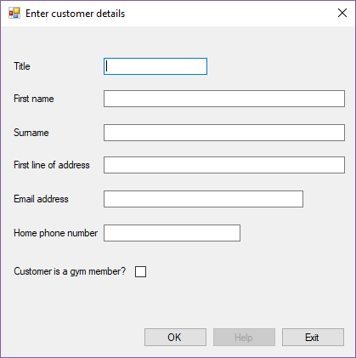

## Login Form

The login form is made up of multiple labels, text boxes and buttons. The window itself is small since it doesn’t contain many controls.

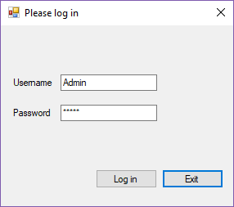

## Gym Form

This is the main form of the application, so I wanted to make sure that the user interface was as user friendly as possible. For the

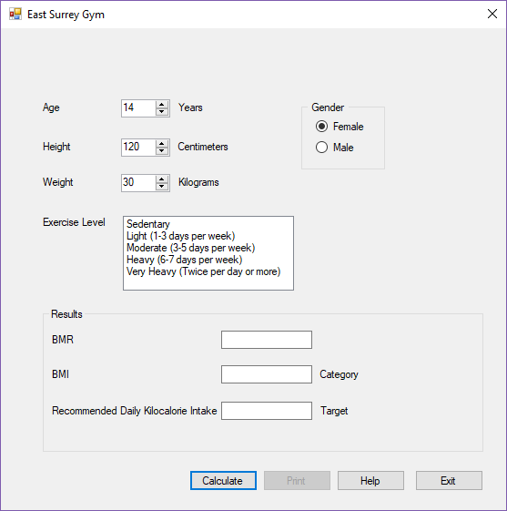

# Class Diagram

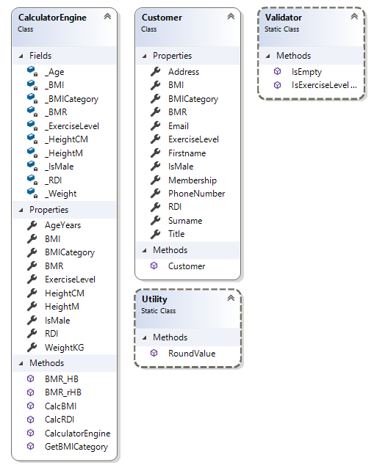

# Classes

## CalculatorEngine.cs

This class is used to create a Calculator Engine object, there is ever only one instance of this class. The class is instantiated multiple times throughout the solution, it stores customer’s health information like their weight and age, then calculates what their BMI & BMR are. Since the application is primarily used to calculate information, these methods are all stored in this class.

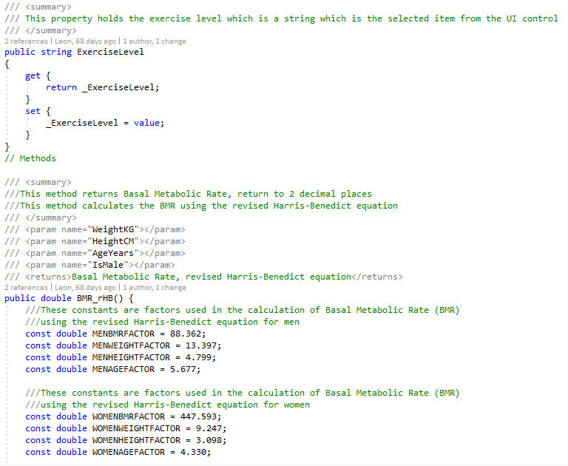

## Customer.cs

This class is used to store Customer information like their name, address and whether they’re already a member of the gym. It doesn’t contain any methods itself as it’s designed to create a Customer object to be used in the Calculator Engine.

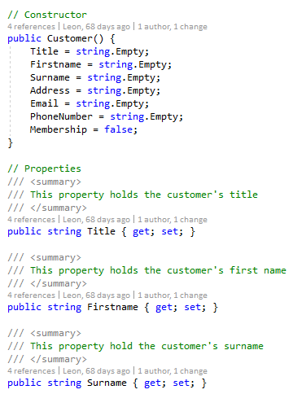

## EnteringDetails.cs

This is the back-end of the “EnteringDetails” form. It is mostly used for validation, Designing the class this way has allowed the application to first make a customer object, then validate it before performing any calculations. Now the calculations will have valid customers before interacting with them.

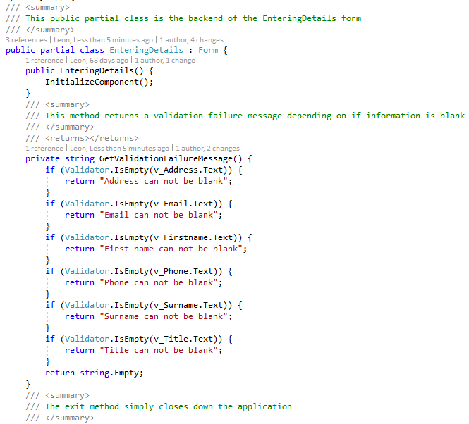

## ESCGym.cs

This is the backend of the “ESCGym” form. It contains methods for calculating the BMI, BMR & daily kilocalorie intake, as well as basic form methods like exiting the application and handling other button clicks like Print & Help. The main method in this class is used to gather values from the form controls like age and weight and then validate them using a try catch statement and assigning them to the CalculatorEngine class. These are then assigned as parameters for a method in the Utility class, these values are rounded to a value set by another parameter, this in turn are used in the CalculatorEngine to calculate the user’s health information. It then sets the form controls values to display the calculated information for the user to view.

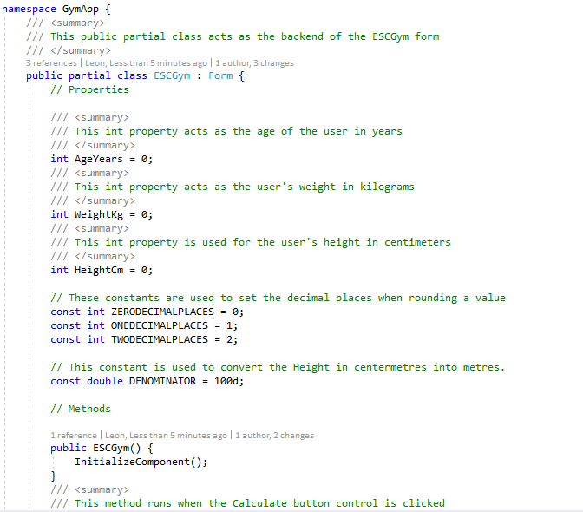

## Login.cs

This is the backend for the “Login” form. Other than a basic exit method, all this class does is check that the user logging in is valid. I originally wanted to allow the user to register multiple accounts, but this was descoped due to higher priorities. The class is structured in a way that should allow adding other accounts easy as well as moving it to a database.

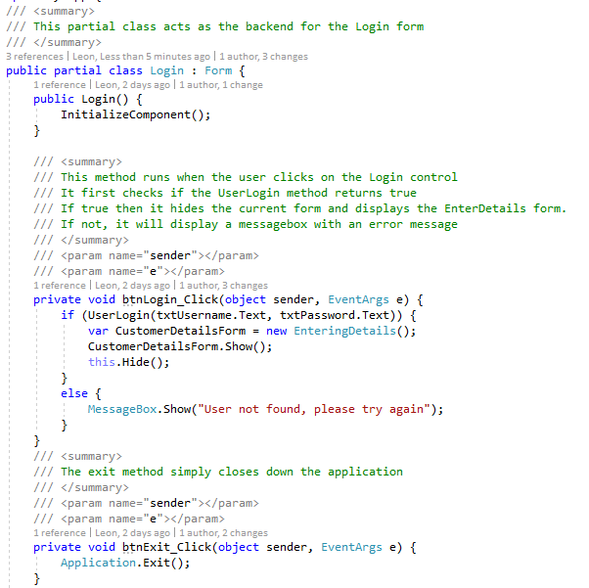

## Utility.cs

The utility class is used for methods that are generic and can be called from anywhere. It currently only has a single method to round a value to a significant figure but can be easily changed to support more methods.

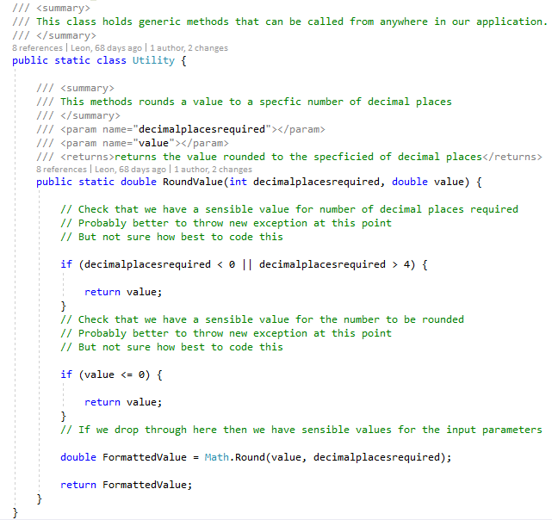

## Validator.cs

Similar to the utility class, the validator class holds generic methods that validate customer information and can be called from anywhere, this can also be easily changed to validate other information like calculations or for inserting data into a model layer.

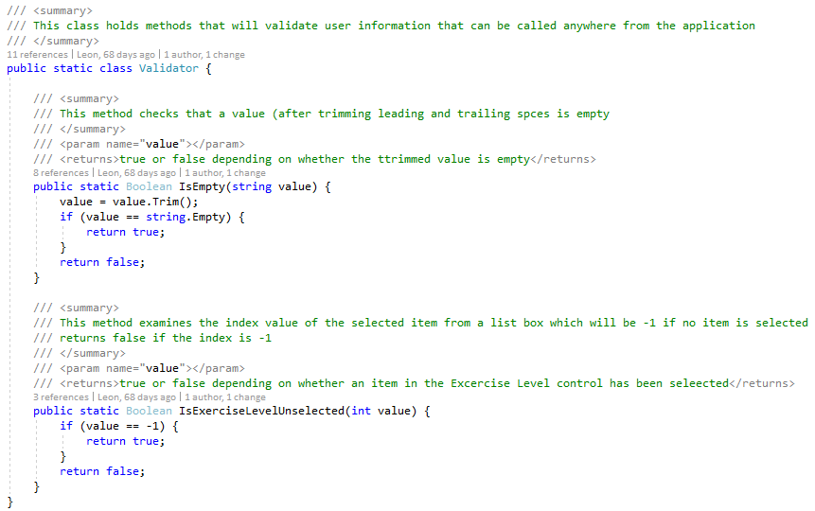

# Properties

## Adding properties

The first initial application didn't have any properties, instead it relied on public static variables in different classes to store and access the information. The revised application however uses properties and fields in classes that must be instantiated. This was a better approach because now multiple customers can be instantiated with different information. It is also useful for further development like printing out a list of customers. This taught me the importance of using classes, objects and properties with proper access modifiers for proper encapsulation.

## CalculatorEngine properties

These properties are used in calculations of BMI, BMR and other information. Customer information is fed to this class which in turn is used in multiple methods and then assigned to new properties like BMI and BMR, which are used in different classes.

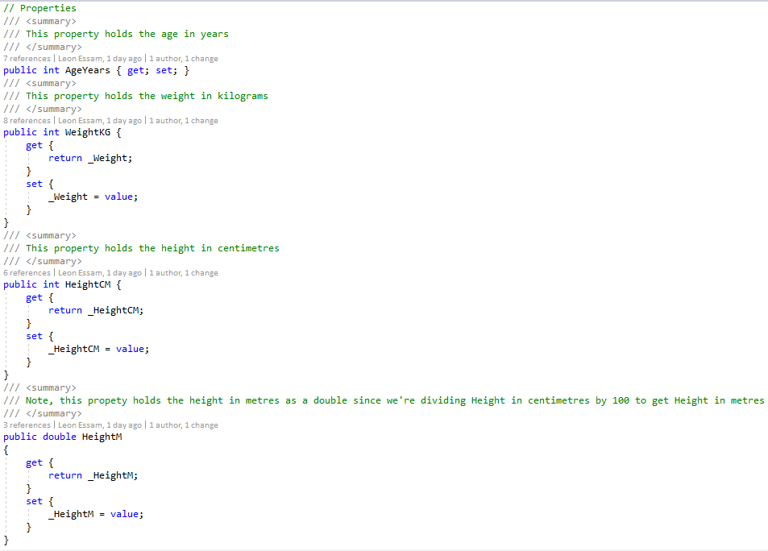

## Customer properties

Customer properties include personal information like name, address and email. These are used to store BMI and other information in the main form. It is currently used this way to create a Customer object which in turn is used in the Calculator Engine class. Although it isn’t used this way, the structure allows this to be easily added to a database.

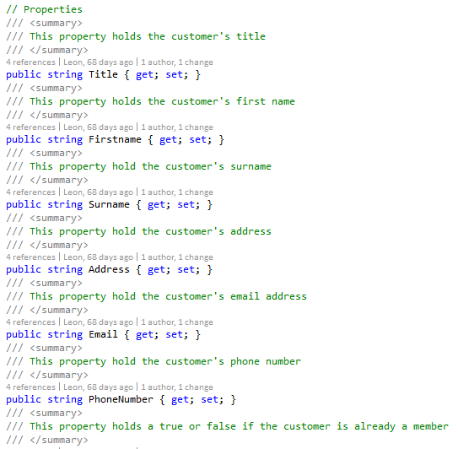

# Methods

## RoundValue : double

This is a simple method in the Utility class, it takes a value and a significant figure for be rounding. I’ve done it this way as it makes maintaining easier and avoids hardcoding values.

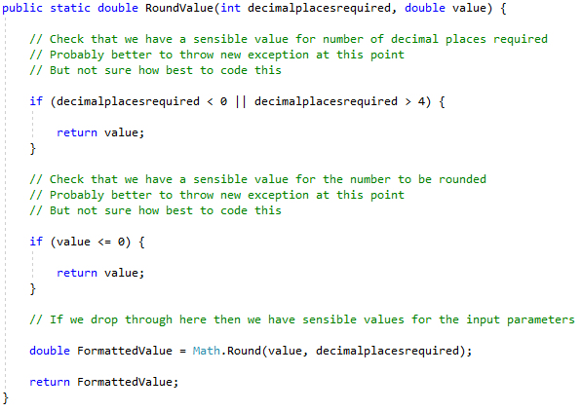

## GetBMICategory : string

This method checks the value of the BMI and returns a string accordingly for their current weight category. This method is easy to maintain since we know the BMI requirements from the scenario, we can use hardcoded values to return the correct BMI category.

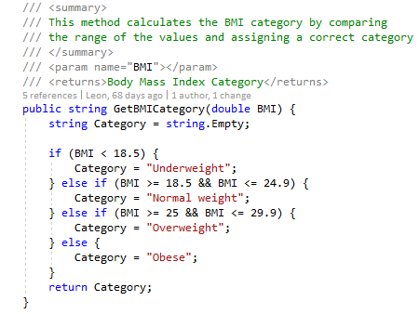

## BMR_HB : double

This method is similar for calculating the BMR, this method however uses the non-revised Harris-Benedict equation, so this allows the gym staff to now choose one of two equations.

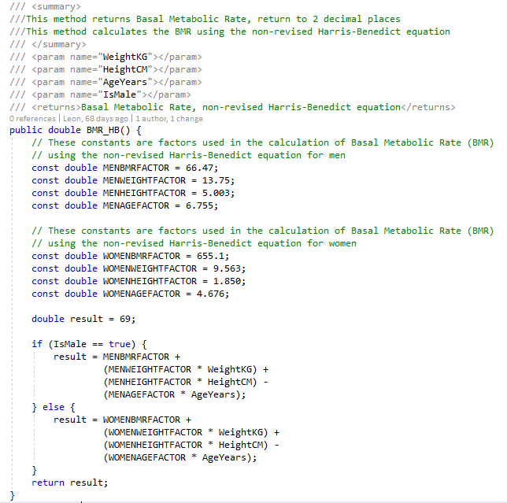

# Testing

## NUnit - Unit Tests

While working on my solution for the application, I started working with Unit Tests to make sure that the methods, properties and classes were all working as intended. This helped save time as I didn't have to worry about launching the program, navigate to what I wanted to check and see if it worked. A new class for unit tests that related to a single class, for example one class would be made for unit tests that all tested one class, then another class for a different set tests for a different class.

## CalculatorEngineTest.cs

CalcRDI is a test that makes sure that the 'CalcRDI' method functions correctly by returning the correct BMI category. First it checks all categories are returned with correct BMI values. Then it checks to see if the application throws an exception if the BMI is invalid. These tests work successfully.

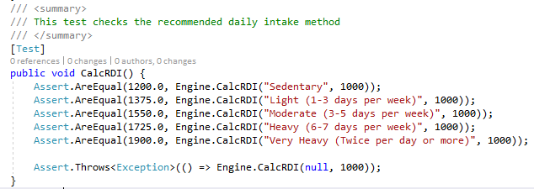

CalcBMI is a similar test in that it checks if the method 'CalcBMI' method functions correctly by returning by the correct BMI value. The test first feeds the CalculatorEngine class basic information then expects a set value that was calculated outside to find the correct value. This test works successfully.

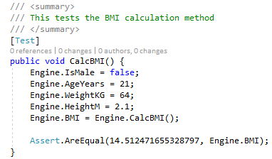

## CustomerTest.cs

This class contains two tests for the customer class, first it checks if the class is being instantiated correctly. The second test ensures that the properties of the class are working by assigning them values then checking the values.

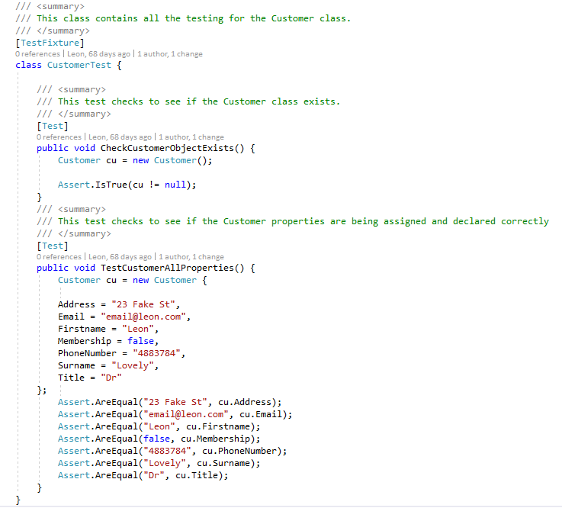

## UtilityTest.cs

Since the utility class only contains a single method, this test class only has one test method. The test is used to ensure that the calculation is correctly rounding values to the right number.

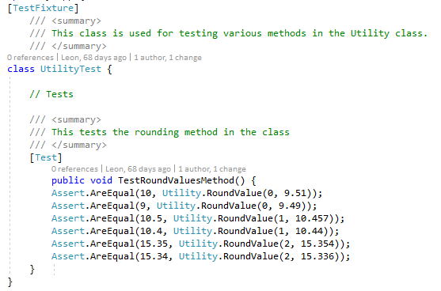

## ValidatorTest.cs

This class holds two tests for the Validator class. 'IsEmptyTestMethod' checks to see if the method outputs a correct true or false depending on if the string is empty. 'IsExerciseLevelUnselectedTestMethod' does something similar by checking that the number is in range.

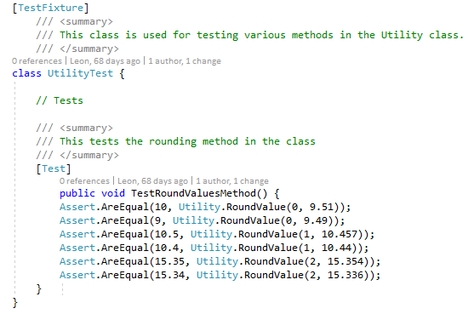

# Review

## Mentor Review

My initial application was reviewed by one of my mentors when I was happy with it. This is just an example but it the whole application was reviewed, and I was to change accordingly.

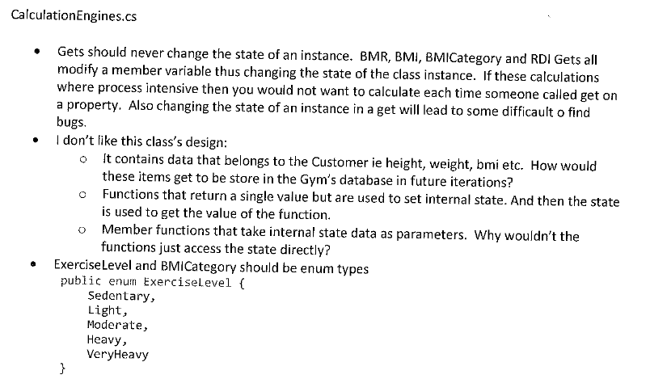

### Development

I worked closely with my mentor during development of this program. This was good because we worked to build the program as more of a product delivered by a junior software engineer than as an assignment. I was introduced to using objects and classes that hold their own appropriate properties and objects. This allowed me to have a much easier to read and maintain program instead of having everything in a main class.

I also used constructors and getters and setters for objects and classes, this made using the Calculator Engine much easier as well as manipulating unique customer objects.

Methods were always a much bigger aspect of the program as now methods were in different classes depending on their use. For example, the calculator class has a BMI calculator method while the utility class has a value rounding method.

Having my program reviewed allowed me to see how a professional developer would tackle the same problems that I encounter or a different method of achieving the same goal.

### QA Testing

This was the first time I used unit testing in my application. I had a small exercise from my C# mentor about how to use NUnit and write them as a professional developer, I found it very easy to implement into the gym application and now all methods, classes and properties are tested in their respective test classes.